Performance Analysis of Human Face Recognition Techniques

Sharmila Department of CSE,

Krishna Engineering College Ghaziabad, Uttar Pradesh,India [sharmila1ece@gmail.com](mailto:sharmila1ece@gmail.com)

Vaishali Puranik Department of CSE,

Krishna Engineering College Ghaziabad, Uttar Pradesh,India [nirmayi.puranik@gmail.com](mailto:nirmayi.puranik@gmail.com)

Raman sharma Department of CSE,

Krishna Engineering College Ghaziabad, Uttar Pradesh,India [ramanisthinking@gmail.com](mailto:ramanisthinking@gmail.com)

Kritika Gautham Department of CSE,

Krishna Engineering College Ghaziabad, Uttar Pradesh,India [kritikagautam96@gmail.com](mailto:kritikagautam96@gmail.com)

Dhanajay Kumar Department of CSE,

Krishna Engineering College Ghaziabad, Uttar Pradesh,India [dhananjay.kumar@krishnacollege.ac.in](mailto:dhananjay.kumar@krishnacollege.ac.in)

***Abstract*— Face recognition has been thought-provoking task in object detection, digital image processing and pattern recognition.Face recognition plays a significant role in real- time surveillance systems. In this paper, we present a comprehensive overview of the state of the art research work on face detection and recognition. Furthermore,the performance analysis of various face recognition approaches are discussed and conclude the paper with future research direction.**

***Keywords—face detection, Haar cascade, face recognition, feature extraction, histogram***

1. INTRODUCTION

Face recognition plays an important role in the numerous fields such as to authenticate the users, security of homeland, smart home access security, identify the criminal, identifying the user in small scale applications. It is mainly used for authentication purpose. Recent technology developmentenables the IoT system generates the real-time data which need to process and analyses the data instantaneously. The detection of object in an image is related to computer technologies and image processing. The main objective of face recognition is to reduce the mis- categorization rate.Face recognition is used in many areas which need more rigorous computation to carry out the face detection. The Haar cascade classifier used to detect the face using OpenCV. The face detector detects the face by means of testing each part of the image. Many face detection methods have been proposed based on machine learning, pattern recognition, meta-heuristic to detect face in the image and video generated from real time surveillance system. In face recognition, the first stage is face detection which has more challenges to recognize the face due to different features in face such as skin texture, color, shape of the face, wearing glasses, and moustache/beard. The photographic environment also affects the occurrence of digital image such as pose of head, facial expression, and lighting conditions. Furthermore, the face detection algorithm used for detecting the other objects such as vehicle number plat identification, pedestrians, etc.

The main contribution of this paper is to analyses the performance of face detection using modified Haar Cascades method.

1. BACKGROUND

Face recognition is used in different applications to identify the faces in the digital image or video frames. It matches the image of person bit by bit. Recently, the face recognition used in the education field[1] to detect, analyses and process the captured image(emotion) to measure the positive effects of teaching such as understanding, insight, and sensations. This method comprises of three phases such as feature extraction, subset feature and emotion classifier. The basic features are extracted using Haar Cascades and sobel edge detection to acquirethe features value.

Face recognition system has been used in small scale area to identify the image from the captured image and videos. The Viola-Jones cascade classifier method is used to detect multiple object in the OpenCV library [2]. The filtering techniques used to increase the accuracy of facial recognition [3]. Graphics Processing Unit(GPU) used along with Viola Jones face detection algorithm to detect face robustly [4, 5, 6]. The emotion and intensions of human being can be easily identify from the face expression [8]. Face recognition is very challenging problem which influences the various applications such as bank security system, identification of human being. Furthermore, it plays significant role in real- time applications such as attendance monitoring, driver drowsiness detection etc.

1. METHODOLOGY

The face recognition is a process of identifying the particular image from the real-time captured image/ live feed. The face recognition approach consists of three modules. Fig.1. shows the modules of facial recognition.



Data set Creator

Trainer

Face Recognition

Fig.1. Modules of face recognition

978-1-7281-1253-4/19/$31.00 © 2019 IEEE



Project the testing face image onto the free space

Get its Eigen face components

1. *Data Set Creator/ Face Detector*

The first stage of proposed method is face detection. One of the best face detector in terms of speed and reliability is Haar-cascade classifier.The training is required for generating new Haar-cascades.In this proposed method, Open Source Computer Vision Library(OpenCV) has been used to generate a robust set of Haar-cascade. Haar cascade was proposed by Paul Voila and Michael Jone. Haar features are important to perceive the occurrence of face in an image using Haar cascade classifier.

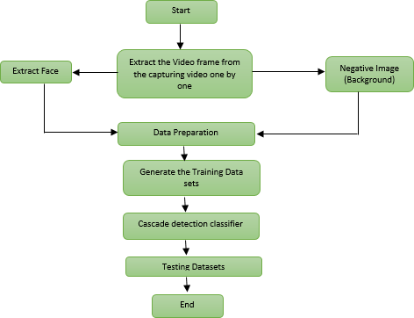

Fig.2. Flowchart of face detection

The random objects identified using face cascades and stable face is detected using eye cascades. The flowchart of the detection system given in the Fig.2.The face detection is carried out by subtracting the sum of pixels of the low intensity area and sum of the pixels of high intensity area. The rectangle features are considered to carry out to detect the features rapidly.

The following expression gives the feature extraction (Eq. (1)),

ƒ(H) = Σ R(Black) —Σ R(White) (1)

Where ƒ(H) = single value haar like ƒeature Σ R(Black) = sun oƒ low intensity eixels

Σ R(white) = sun oƒ high intensity eixels

In OpenCV, the classifier class is used through cv2 to create a face and eye classifier objects. The respective XML files and CascadeClassifier () are loaded. The cv2 is used to create camera image. And inorder to capture the images the

VideoCapture() commands are used. To match the various sizes and to find the location the CascadeClassifier.detectMultiScale () object. Using the location data, the face is cropped for further verification. Eye cascade is used to verify there are two eyes in the cropped face. If satisfied a marker is placed around the face to illustrate a face is detected in the location.

1. *Trainer*

The trainer set is a way to determine the relationships between different /same data sets in diverse contexts.

1. *Face Recognition*

In this paper, the three algorithms are implemented independently and analyzed the performance with respect to the accuracy. These are Eigen face, Fisher face and Linear Binary Pattern Histograms (LBPH) respectively. OpenCV libraries is used to implement the above methods. The face recognition can be carried out by three phases as follows:

* 1. Gather theImage IDs
  2. Extricate the unique features of image and classifying them and store it in XML files
  3. Matches the unique features of a given image to the features which stored in XML files and predict identity.

The following section provides the detailed information about above mentioned face recognition algorithms.

1. FACE RECOGNITION TECHNIQUES

The numerous face recognition techniques have been proposed to extract the features from the pre-processed images.

1. *Eigenfaces*

One of the most popular method to recognise the face is Eigenface which is based on Principal Component Analysis (PCA). The face images are predicted into a feature space which express the variations among the known face images. This face space is defined by theeigenfaces. The eigenfaces is the eigenvectors of the set of faces.



Acquire training samplea

Estimate the Eigenfaces

Project the face images onto the face space

Estimate the euclidean distance between the input face images and training samples

Fig.3. Face recognition process based on Eigenfaces

Steps in Face recognition:

* 1. *Initialization:* Gather the training set and estimate the eigenfaces using PCA which state eigenspace.
  2. *Calculation of eigenfaces*
  3. *Calculation of eigenvectors*
  4. *Training the set*
  5. *Represenation of face images using eigenfaces*

1. *Fisherfaces*

Fishersfaces approach is based on Fisher’s Linear Discriminant Analysis (LDA). In some cases, the Fishersfaces is faster than Eigenfaces. It works well in different lightning conditions and facial expressions. Fig.4. shows the process of Fishersfaces



Fetch images from database

Compute the average of all the faces





Subtract average face of eac person from training faces

Compute average of each faces



Build scatter matrices

Fig.4. Face recognition process based on Fishersfaces

1. *Local Binary Patterns Histograms*

Local binary pattern is most efficient method to label the texture and shape of a digital image. This approach is the combination of histogram and local binary pattern which increase the performance of certain datasets.

The steps to implement LBPH is as follows,

* 1. *Parameter selections:*It uses four parameters such as
     1. *Radius*
     2. *Neighbors*
     3. *Grid X*
     4. *Grid Y*
  2. *Training the algorithm:* Initially, the datasets need to be created for facial image of the persons need to be recognize and assign the identity (ID) for each person. The identity may be either number or the name of the person. The

algorithm uses this identity to recognize an input image and gives an output.

* 1. *LBP operation:* The initial step of the LBHP is to generate an intermediate image which highlights the facial features. It uses the sliding window concept based on radius and number of neighbors.For example, consider the matrix of size 3× 3in which the center value is considered as threshold value. If the neighbor value is greater than or equal to threshold, then it assigns 1 else 0. Then concatenate all the binary values and convert it into decimal and replace the central value of matrix by decimal value. This process generate a better characteristic of the input image.
  2. *Extract the histograms for the image*
  3. *Perform the face recognition:* Using the above mentioned steps, the algorithm is trained. The image needs to matches with trained image and return the closest histogram. The matching process is carried out by many techniques such as Euclidean distance, absolute value, chi- square, etc. In this paper, the Euclidean distance approach is used to perform matching.

1. RESULT AND DISCUSSIONS

OpenCV 2.7[7] is used to analyses the performance of the three face recognition algorithm such as Eigenfaces, Fishersfaces, and LBPH in order to detect face from the images. Fig.5.and Fig.6. shows the multiple face recognition using LBPH and trainer sets process to convert .xml to .yml file. Table I shows the data set creation of different images. Table II shows the accuracy of three different methods. Table.II infers that the accuracy of LBPH is better than Fisherfaces and Eigen faces.

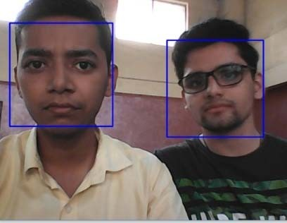

Fig.5. Multiple face recognition using LBPH.

REFERENCES

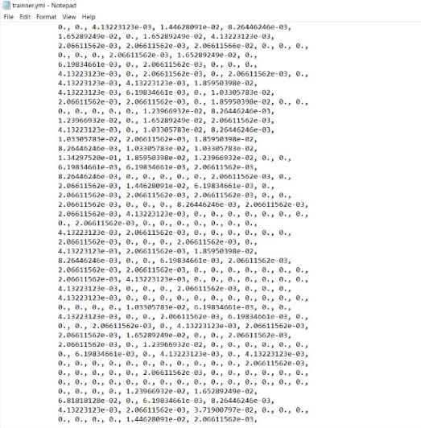

Fig.6. Trainer data sets

TABLE I. DATA SET CREATIONS

|  |  |  |
| --- | --- | --- |
| Images | DataSet Creation  time | Training time |
| 100 images per  person | 31 sec | 4 sec |
| 150 images per  person | 56 sec | 4 sec |

TABLE II. COMPARISON OF THREE DIFFERENT METHODS

|  |  |
| --- | --- |
| Algorithm | Accuracy of detection |
| LBPH | 80 |
| Fisherface | 78 |
| Eigen face | 70 |

1. CONCLUSION

Face recognition is a most extensive research field in the area of image processing. In this paper, we have studied the extensive analysis of face recognition and detection techniques in terms of accuracy and runtime. The result shows that using LHBP the multiple faces are detected at a single trainer set and its accuracy is high as compared to Fisherfaces and Eigen faces. There are numerous challengesand issues in face recognition when it comes to the real-time applications. Future work would include a comprehensive study to recognize the faces at various angles.

1. D. Yang, Abeer Alsadoon, P.W.C. Prasad, A.K. Singh, A. Elchouemi,

“An Emotion Recognition Model Based on Facial Recognition in Virtual Learning Environment”, Procedia Computer Science, Vol. 125, pp.2-10,2018.

1. N. Kazanskiy, V. Protsenko, P. Serafimovich, “Performance analysis of real-time face detection system based on stream data mining frameworks”, Procedia Engineering, Vol. 201, pp. 806-816, 2017.
2. Vinay A., G. Kathiresan, D. A. Mundroy, H. Nihar Nandan, C. Sureka, K.N. B. Murthy, S. Natarajan, “Face Recognition using Filtered Eohsift”, Procedia Computer Science, Vol. 79, pp. 543-552, 2016
3. V. Jain, D. Patel, “A GPU Based Implementation of Robust Face Detection System”, Procedia Computer Science, Vol. 87, pp. 156- 163, 2016.
4. V.E. Machaca Arceda, K.M. Fernández Fabián, P.C. Laguna Laura,

J.J. Rivera Tito, J.C. Gutiérrez Cáceres, “Fast Face Detection in Violent Video Scenes”, Electronic Notes in Theoretical Computer Science, Vol. 329, pp. 5-26, 2016.

1. N. Kazanskiy, V. Protsenko, P. Serafimovich, “ Performance analysis of real-time face detection system based on stream data mining frameworks”, Procedia Engineering, Vol. 201, pp. 806-816, 2017.
2. Open source computer vision library <http://sourceforge.net/projects/opencvlibrary/>
3. W. Zhao, R. Chellappa, P. J. Phillips, and A. Rosenfeld,“ Face recognition: A literature survey” ACM Computing Surveys (CSUR), 35(4):399{458, 2003
4. Teddy M, Suhendi, “ Multi-faces recognition process using Haar Cascades and Eigenface Methods”, 6th International Conference on Multimedia Computing and Systems(ICMCS), pp.1-5,2018.